

Q1:

Software Requirements Specification

for

Ticket Tracking System
Version 1.0 approved
Prepared by
Vo Minh Toan SE194279
FPT University HCM Campus
Jul 27, 2025

Q2:

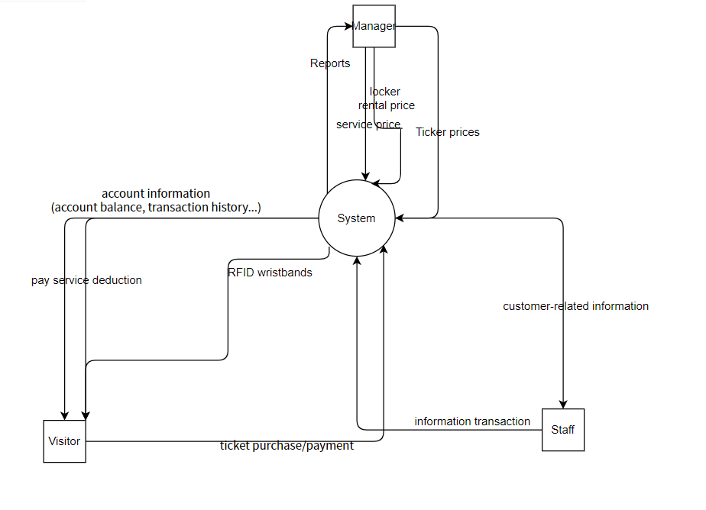

Q3:
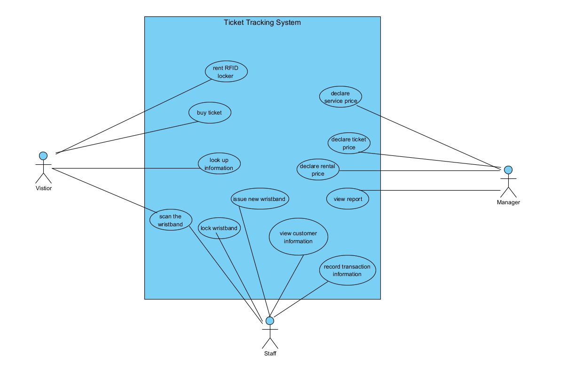
# | Actor | Description
01 | Visitor | The actor who uses the directly services in the water park
02 | Staff | The actor who directly manages
03 | Manager | The actor who manages all services including prices

# | Use Case | Actors | Description
UC-01 | Buy ticket | Visitor | Buying ticket for using service by using wristband
UC-02 | Scan the wristband | Visitor, Staff | Scan the wristband for further services or actions
UC-03 | Look up information | Visitor | Visitor looks up information such as account balance, transaction history, used services
UC-04 | Lock the writsband | Staff | Lock in case customer lose the wristband
UC-05 | Issue new writsband | Staff | Issue new in case customer lose the wristband
UC-06 | View customer information | Staff | View customer-related information
UC-07 | Record transaction information | Staff
UC-08 | Rent RFID locker | Visitor | Rent locker to put items
UC-09 | Declare tikcet price | Manager
UC-10 | Declare service price | Manager
UC-11 | Declare rental price | Manager
UC-12 | View report | Manager | View report to manage number of visitors and ticket status

Q4:

# | Entity | Description
01
02
03

